Bibliography
Personal independent reading (that not set as tasks by tutors)
- Source (Harvard referencing system) NHS. (2012). NHS authorities and trusts. Available: http://www.nhs.uk/NHSEngland/thenhs/about/Pages/authoritiesandtrusts.aspx#primary. Last accessed 7th Oct 2012.
Why did I choose to read this? One of the articles we were set to read in the education studies module (Alexander, R. (2010) Ch4 in Children, their World, their Education:final report from the Cambridge Primary Review. London:Routledge) referred to 'primary care trusts' in a section about the 2004 Children Act, and I was unsure as to what these were, so I looked it up!
Key points I learned through the reading of it
- That a 'care trust' is an organisation which aims to address social and health care needs, a partnership between the NHS and local authority organisations.
- That a 'primary' care trust is the organisation providing the services needed within a community to provide a first port of call when you first present with a health problem.
- That 'primary care' includes services performed by a doctor, dentist, optician, or pharmacist, NHS walk-in centres, and the NHS Direct telephone service.
Source (Harvard referencing system
Moon,J.A. (1999). Reflection in Learning & Professional Development Theory & Practice. New York: RouteledgeFalmer. p3-10,25,71,100,122,138,158.
Why did I choose to read this? As a tool to help me to develop my understanding of what reflection is, and what the purposes of reflection are.
Key points I learned through the reading of it
- The idea that reflection happens unconsciously and is the basis of 'intuition', and that the study of reflection enables us to be conscious of our reflecting processes and apply them consciously.
- That 'reflection' means different things to different people. That there are different theories as to what reflection is and what the aims of reflecting are and that these are represented in different models of reflection'.
- That while there are considerable differences across theories as to what constitutes reflection, there is consensus that it involves a basic mental process applied to gain understanding where material is 'ill-structured 'or uncertain and..[has] no obvious solution', and that reflection has a purpose and/or outcome aspect to it.
- Some of the different models of reflection: Kolb's model of reflection:

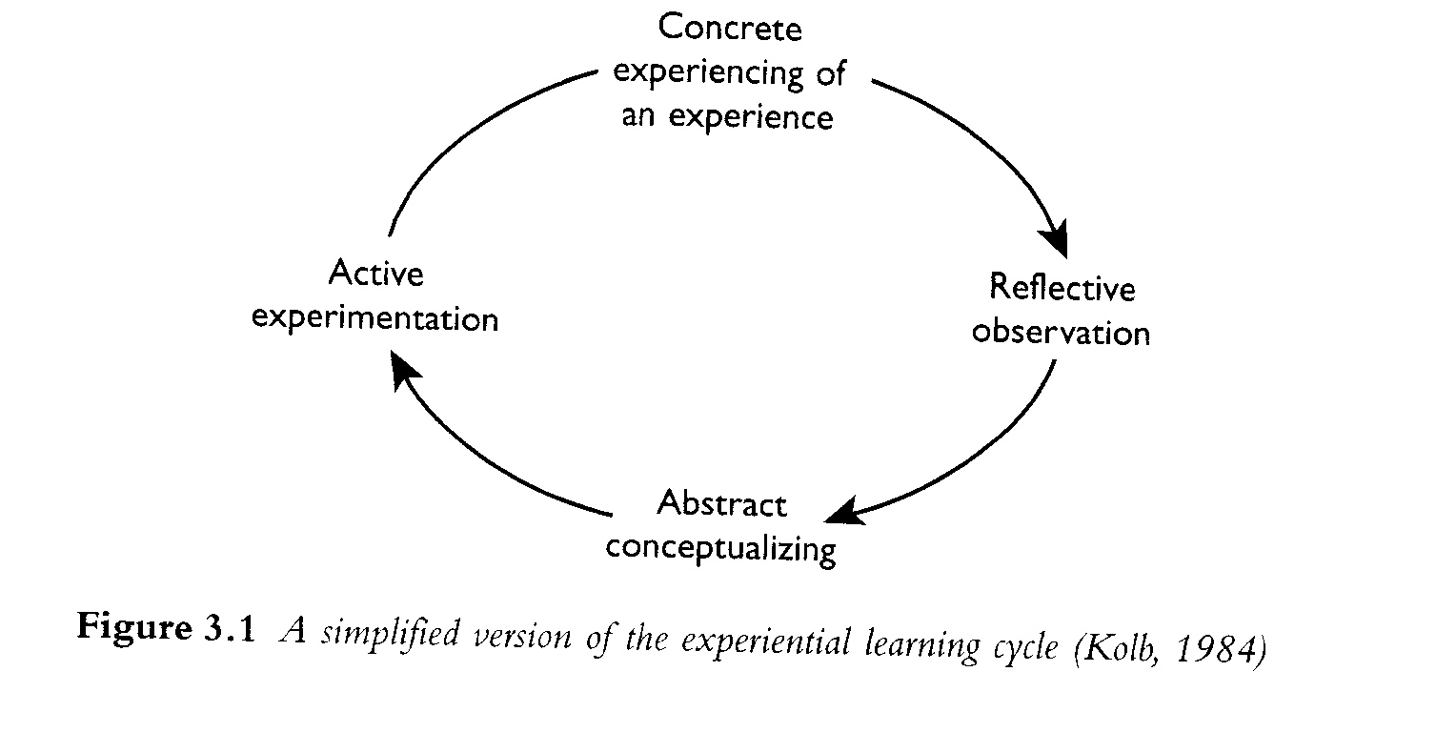

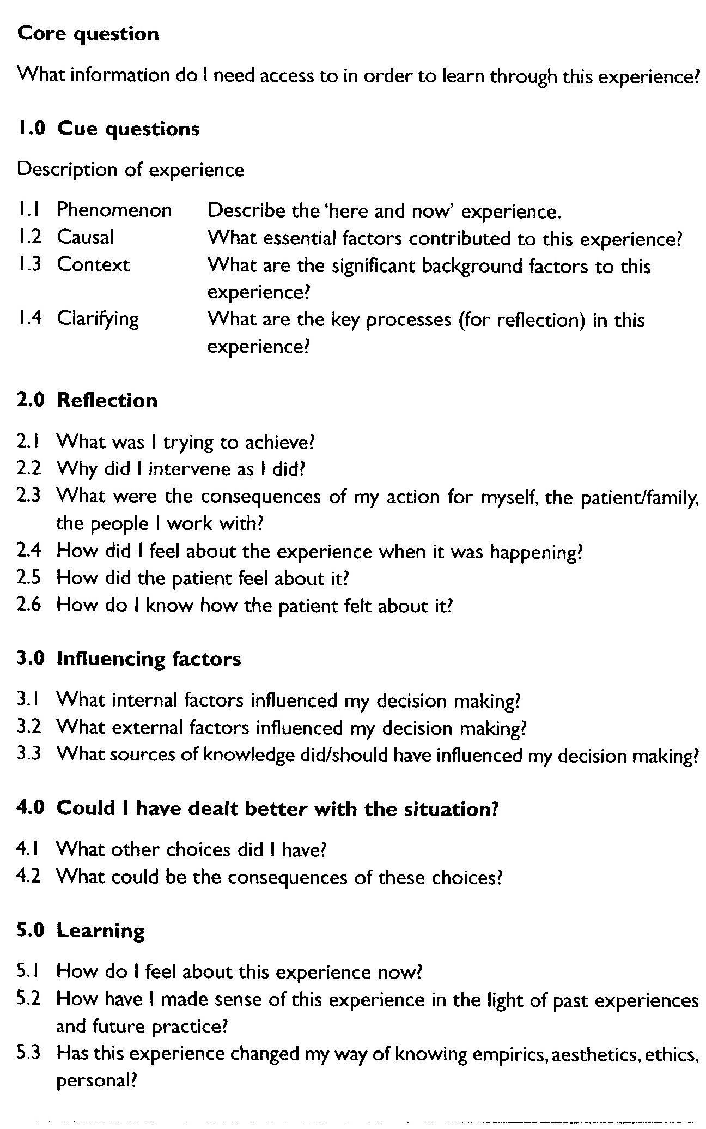
- Johns' model of reflection:

an imput-output model of reflection:
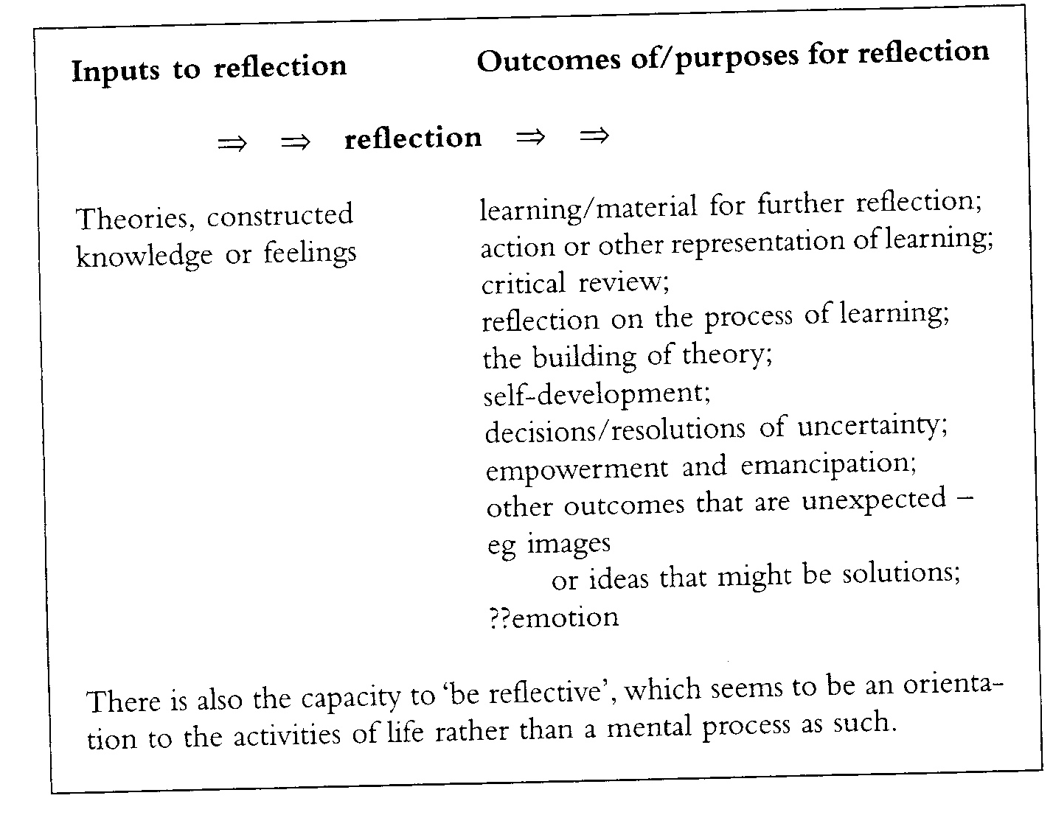

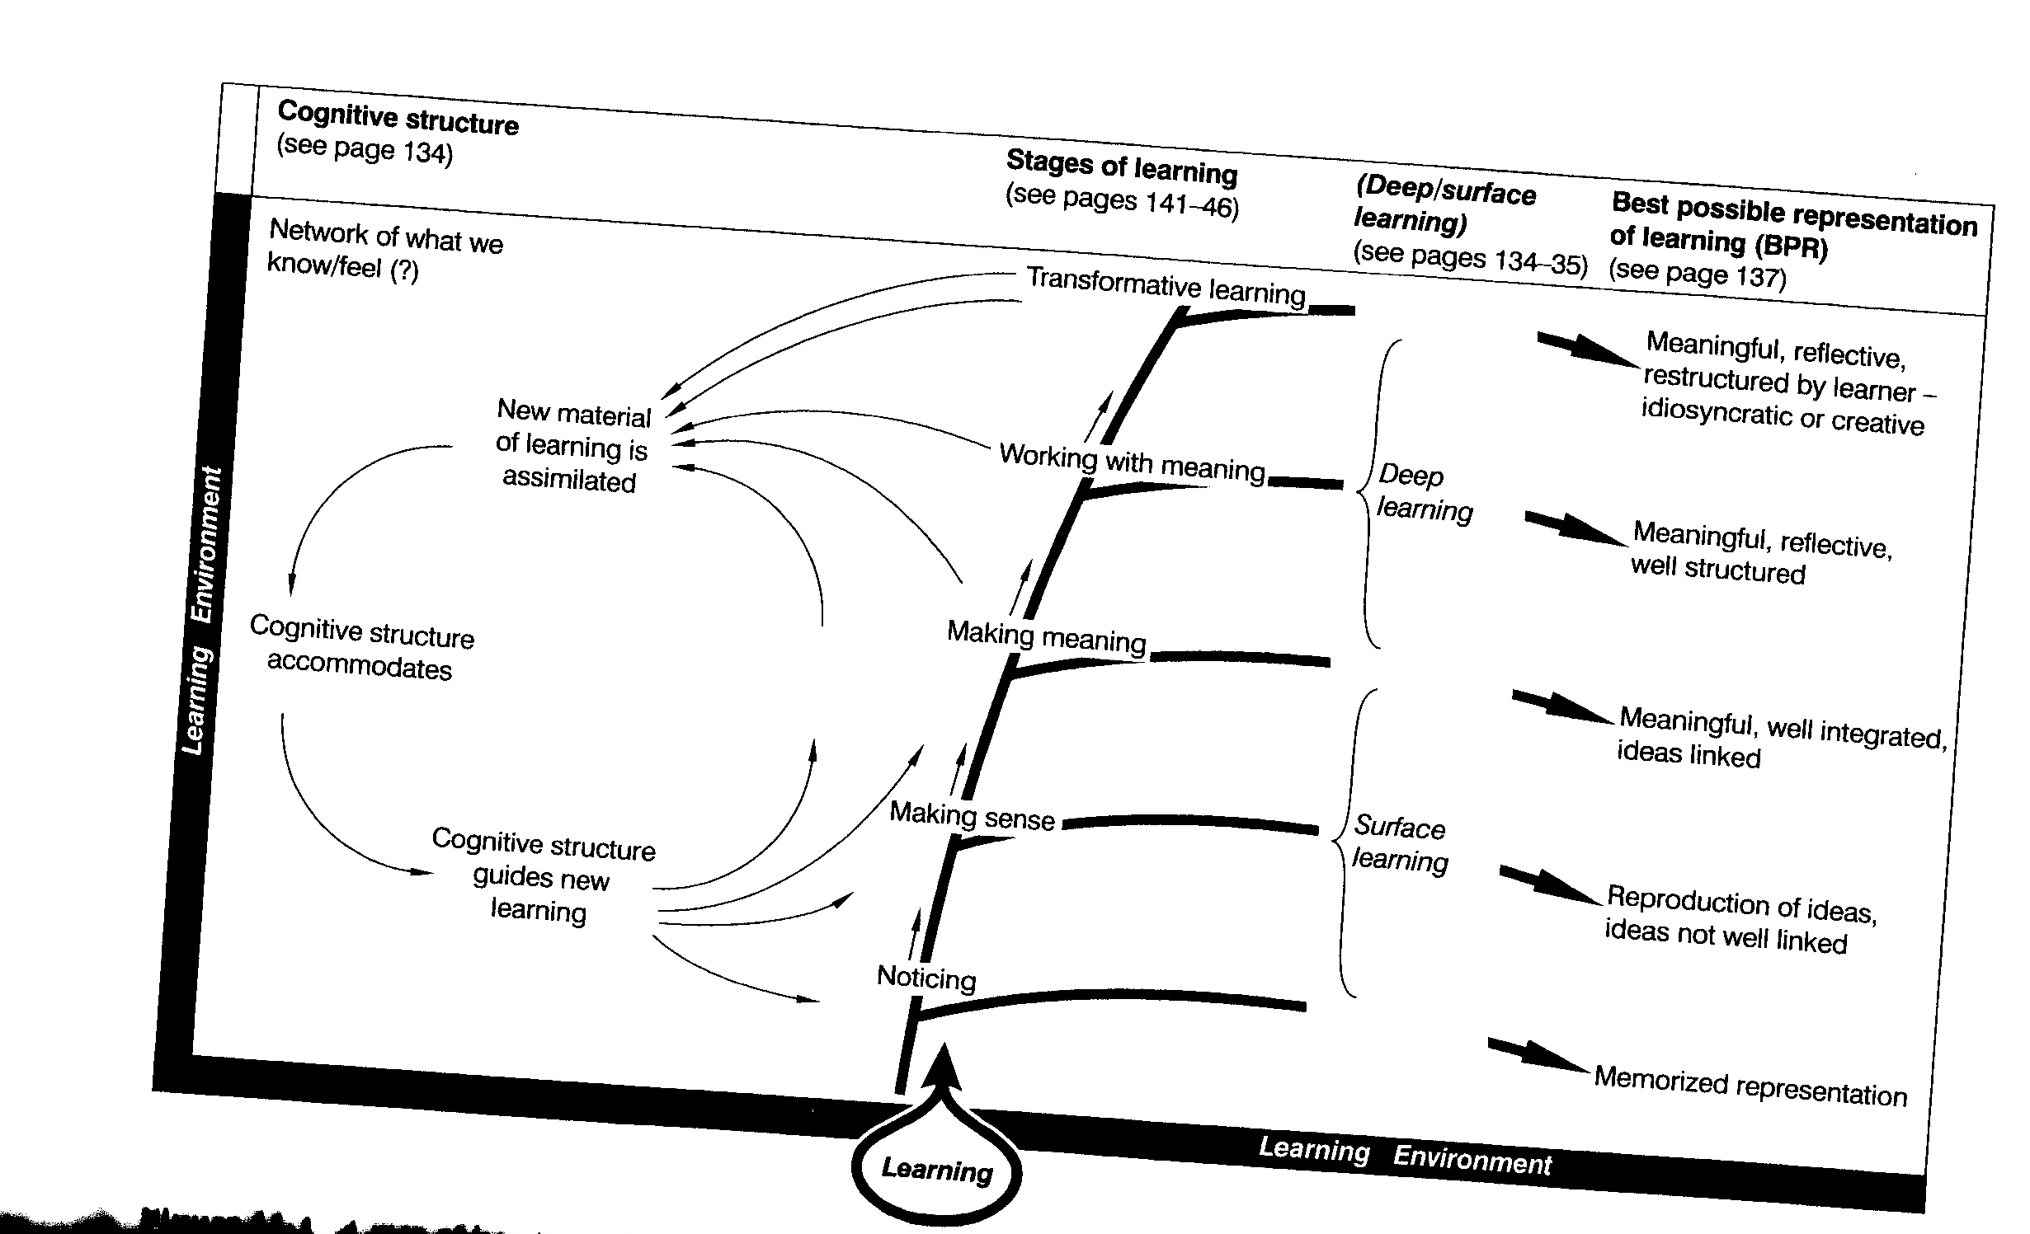
- an idea of the process from reading to reflecting to outcome of the experience:
- different purposes or outcomes of reflection:
- to understand something you didn't know before (whether you knew you didn't know it or not)
- developing yourself, your views, understanding, and mental processes
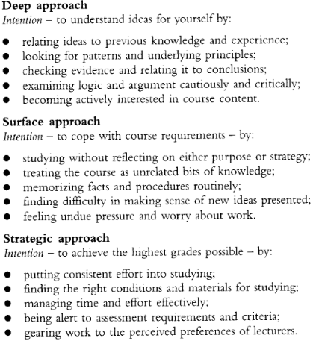
the differences between deep, surface, and strategic learning styles

- that there is a role that emotions play in reflection, but the nature of their involvement in the process of reflection is uncertain
Questions raised through the reading of it
- What other models of reflection are there?
- How can I integrate different models of reflection for my own reflection so as to get the most out of my learning ?
is an emotional response incidental to reflection?, do emotions affect your ability to reflect and what you take out of reflection?, are emotions an integral and essential and desired part of reflection?
- Source (Harvard referencing system)Brookfield,S.D. (1995). Becoming a Critically Reflective Teacher. San Francisco: Jossey-Bass. p1-48.
Why did I choose to read this?As a tool to expand my understanding of reflection, and how it links to teaching as well as to learning.
Key points I learned through the reading of it
- That intentions alone cannot ensure high quality learning or teaching, and that reflection is a valuable tool which we can use to increase the probability of better future learning and teaching.
- That we need to be constantly self-reflective in teaching so as to avoid the possibility of our pupils taking a different meaning from our words and actions from those we intended with them.
- Flaws in popular approaches to teaching. And that the fact that the approaches have flaws does not mean that they are not worth using, but that it is important to bear them in mind and try to employ strategies to overcome them if possible; and the importance of not just blindly trend-following in your teaching styles and techniques.
- That complex problems do not have simple answers. That they might not have answers at all, but instead ways of managing the problem, and that the key is to discern better and worse problem-management strategies for different scenarios and to implement them reflectively.
- That without self reflection and analysis, we cannot discern what is within our power to control and what is not, and what we have responsibility for and what we do not; and therefore we cannot make realistic plans for the future based on the learning experience. Without true, critical (though not necessarily negative) self reflection in teaching we risk blaming ourselves for things we are not to blame for, and not taking action where we are should and are able to affect positive changes. Therefore, self-reflection can be seen as a tool to promote objectivity and recognise/avoid assumptions.
- The possible unintended negative effects which common-sense, well-intended teaching actions can have on pupils. This reinforced to me the importance of trying to think about the possible (mis)interpretations of your actions as a teacher, and possible unintended consequences of actions, and therefore the need to weigh up the pros and cons of actions and techniques before applying them. This provided a turning point in my understanding of teaching practices, and highlighted to me that it is not possible to be a perfect teacher no matter how well informed or well intentioned; and that there is no teaching technique without its own possible pitfalls.
- Some ideas as to why critical reflection is important:
- 'it helps us to take informed decisions', minimizing risk
- 'it helps us to develop a rationale' for why we do or do not do things
- 'it grounds us emotionally'
- Source (Harvard referencing system)Gillard, D. (2011). Towards a state system of education . Available: http://www.educationengland.org.uk/history/chapter02.html. Last accessed 8th Oct 2012
Why did I choose to read this?I realised that I did not actually know what the 'three Rs' stand for although I knew that they were to do with maths, reading and writing skills, and I was interested in finding out what the frequently used phrase actually means and where it comes from in the history of education.
Key points I learned through the reading of it
- That preparatory schools are English fee paying schools traditionally aimed at middle and upper-class families' children with the aim of preparing the children for attending 'the great English public schools' – i.e. that it's traditionally inferred purpose is to prepare children for later education, rather than as a stage in its own right.
- That the term 'preparatory' is not actually legally established, so it has no formal meaning, but infers meanings.
- That the 'three 'Rs'' is a phrase which is thought to date back to the time of Lancaster and Bell and 'monitored schools' (in the early 19th century) when 'reading, writing and 'rithmetic)' (attributed to Sir William Curtis) as well as 'practical activities' were introduced as key aspects at the foundation of a new curriculum.
- Source (Harvard referencing system)Atherton, J S. (2011). Learning curves. Available: http://www.learningandteaching.info/learning/learning_curve.htm. Last accessed 8th Oct 2012.
Why did I choose to read this?I wanted to find out more about the theory of stages of learning linking with our perceptions and self-awareness.
Key points I learned through the reading of it
- That there is a 'progression of competence' model of learning (though to whom it can be attributed is not known) which lists levels of understanding which correspond to the idea of a progression of moving from what you don't know you don't know, something.
- That the stages of the 'progression of competence' model of learning are:
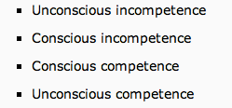

- through to knowing that you know competence' model of learning - 'unconscious competence' is parallel to the stage of Reynold (1965)'s model of learning where something becomes second nature to you. And that Reynold thought that it was only at this level of understanding something that you could teach it to someone else.
- That there are many different, differing, models based on this concept – and that Reynold's model of it comes from the perspective of there being an extra dimension (to the movement from lack of knowledge that you don't know something to knowing you know something ) that is the attainment of consistency at each level – which is pictorially represented below(The horizontal line represents a notional threshold of “competence”)
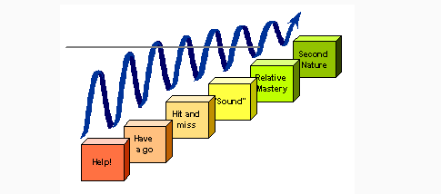

- Source (Harvard referencing system)Aldrich, F and Sheppard, L. (2000). ‘Graphicacy’: the fourth ‘R’?. Primary Science Review. 64 (8-11), p1-7.
Why did I choose to read this?I wanted to make sure that I understood what the term 'graphicacy'(referred to in our geography session this week) meant.
Key points I learned through the reading of It
- That 'graphicacy' is:
'the ability to understand and present information in the form of sketches, photographs, diagrams, maps, plans, charts, graphs and other non-textual, two-dimensional formats'

i.e. learning to represent and interpret representations of things and ideas in pictorial form – whether it be a direct or abstract or numerical representation.
- That a sound grasp of graphicacy be advantageous with or instead of text because:
- it helps to set a scene
- visual representations are memorable

- that although children come into regular contact with visual representations naturally, there is a convincing argument that we should teach graphicacy (from primary school level) rather than expecting children to pick up the skills on their own – as otherwise there is a distinct risk of misconceptions being allowed to go unchecked and to gradually reinforce themselves over time; such that they (and the adults they grow to become) may be unable to understand or create pictorial representations accurately or effectively.
- That 'graphics' means 'visual representation'
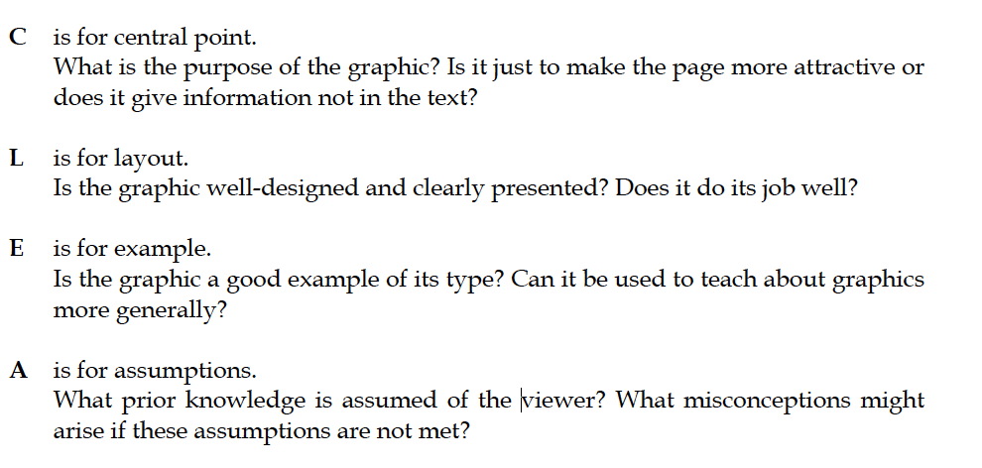
- A simple way to remember (and teach pupils to remember) the criteria to apply when looking at graphics (CLEAR):
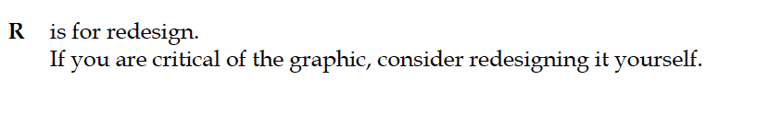

- Source (Harvard referencing system)Cooper, B and Dunne, M. (1999). Anyone for Tennis? Social Class Differences in Children's Responses to National Curriculum Mathematics Testing. In: Murphy, P. Learners, Learning & Assessment. London: The Open University, Paul Chapman Publishing Ltd. p305-328.
Why did I choose to read this?Two of the articles we we have so far been set to read in the education studies module (Alexander, R. (2010) Ch4 in Children, their World, their Education:final report from the Cambridge Primary Review. London:Routledge; and Bartlett, S. and Vurton, D. (2012). Introduction to Educational Studies. London: Sage.) referred to the widening economic gap between advantaged and disadvantaged children, and that this could have an effects on the children's educational experience (in primary school); and I wanted to find out more about the effects of economic differences on primary education.

Key points I learned through the reading of it
- I do not feel that this chapter provided me with an understanding of the evidence for there being social-class links to educational performances, or for the reasons behind them (which is what I had sought from the chapter). Although I felt that the chapter put forward some very interesting points which have influenced my thinking about how to phrase questions to best test pupils' knowledge and skills, I found the authors' overall argument to be flawed and not compelling.
The authors argued that the chapter provided evidence that mathematical test-results of primary school children are linked to social classes because different social classes tend to differentially interpret mathematical questions set in 'real-life' contexts.
The favoured approach at the moment (since the 1982 Cockcroft report) is to approach mathematical problems using a 'real-life' context (rather than through ''abstract' algebraic approaches' (p306)) with the aim that pupils will be more able to see the relevance of the mathematical problem to their present or future lives- and therefore be more enthusiastic about/amenable to learning how to solve the problem. I must admit that before reading this article, I had not questioned this argument although I had myself been a pupil who had sometimes got the answer 'wrong' because I had misinterpreted the question as a result of the context in which the question was set – such that I would get the answer 'wrong' even though I might have been able to apply the mathematical methods correctly. I found this argument to be compelling and challenging to my previous assumptions.
I was interested by the authors' argument that mathematical questions set in 'real life' scenarios can lead to children getting the mathematical answer wrong, although they may have understood the question, and may be able to answer the mathematical question 'correctly' when put to them directly. Children can find alternative solutions to problems when they are faced with a 'real-life' problem to solve – and their solutions may well work in real life, but the solution may not be the correct one mathematically. The authors give the example of long division problems put into the scenario of there being too many people to fit in a lift which has a maximum number of people, where the pupil is asked to work out how many trips the lift will have to make. The 'correct' way of answering the question is to divide the number of people by the number of people the lift can take at any one time, and round the number up to the nearest whole number if the answer is a decimal because you cannot have a fraction of a person travelling in a lift. However, pupils might consider that the lift need not always travel to full capacity, some people might take the stairs etc, giving the pupil a different answer. The task might have been solved, but the mathematical problem may not have been.
Similarly, the authors give the example of a mathematical question based on finding how many possible girl-boy pairs you can make from a set list of names. The 'correct' way of answering the question is to systematically pair up every boy with every girl, and add up the number of possible pairs you can make overall. However, pupils might consider assumed nationality (based on the name type) because of the sporting-context.
I found these thoughts and findings from the study to be fascinating as they made me appreciate the fine art which is forming a question which tests only what you want to test, and leaves no room for misinterpretation.
However, I did not feel that their study showed convincingly that the differences in interpretations of the questions were directly linked to the pupils' social-group. I felt that the studies only showed differences on an individual basis, and there was a lack of evidence that the individual's interpretation was a result of their social-class.
I felt there was a lack of evidence for the link proposed (between the pupil's interpretation of the question and the pupil's social class) because:
- there was no control element/ there was no proof that the similarities between pupils' misinterpretations were linked to their social-class, or to what extent
- the groupings of types of misinterpretation were broad (e.g. esoteric/other/realistic) and therefore the answer-type/reasoning of pupils put into any one group may not have been significantly similar, in which case the social links between pupils in any one group would have been insignificant in terms of their interpretation of mathematical questions
- there was a lack of consistency such that the study's findings were not reliable – the groups (into which pupils were put depending on their answer 'type') changed from study to study, but the overall findings were based on the authors drawing conclusions by comparisons between studies (so like was nit compared with like)
- the pupils' ages was not a control and this may have also had an influence upon the 'type' of answer a pupil gave (140 of the pupils were in primary school and 450 in secondary school, yet there was no differentiation made between the results)
- furthermore, the study was on a relatively small-scale (only 590 pupils) so any results found may not be representative of the population as a whole.

Overall I felt that the study was conducted in a way which failed to control some significant factors which might have influenced pupils' results (other than that for which they were testing – social-class), its tests were inconsistent, the groupings made not evidence-based yet used to draw evidence from, and the study small in scale. Therefore I did not find the conclusion proposed (that when answering mathematical problems set in real-life contexts, there is a significant link between social class and the types of misinterpretations made by pupils) to be compelling. However, I did find the arguments put forward (for the potential failings of 'real-life' question contexts ) to be challenging and compelling in themselves.
Questions raised through the reading of it
What do we aim to find out about pupils from tests?
How can we assess a pupil's knowledge and skills which we have taught them without any outside influences?
What should be rewarded from tests: getting the right answer no matter how it is reached? Using the taught method no matter if it is understood? Finding a solution to the problem proposed even if it is not the one the pupil was 'meant' to find? Using intelligence? Using knowledge?
Is there compelling evidence for social class links to test results? Why do the links exist? What can we do to break down social-class influences? Should we do so?
Is there a link between social-experiences and social-class? if so, do these social experiences impact on pupils' interpretations of 'real-life' contexts used in questions in schools? i.e. do pupils of certain social backgrounds have the same 'real-life' experiences as those from other social backgrounds, and if not; do schools' 'real-life' contexts for questions cater equally to all pupils?
- Source (Harvard referencing system)Banks, F. Leach, J. and Moon, B. (1999). New Understandings of Teachers' pedagogic knowledge. In: Leach, J. and Moon, B. Learners & Pedagogy. London: The Open University. Paul Chapman Publishing Ltd. p89-111.
Why did I choose to read this? One of the main focuses of our Geography and D+T sessions this week has been looking at what you can learn (in terms of skills, knowledge, and understanding) from each of these subjects as a pupil.
I was therefore interested in looking at this from a teacher's perspective – what does a teacher have to know to be an effective teacher of a subject so as to be able to deliver the lessons in a way that enables your pupils to have the opportunity to learn this plethora of potential skills and knowledge and understanding?
Key points I learned through the reading of it
Questions raised through the reading of it

- Source (Harvard referencing system)
Why did I choose to read this?
Key points I learned through the reading of it
Questions raised through the reading of it

